Dis-Afr-Tanzania-Makonde Mask-early 20th century

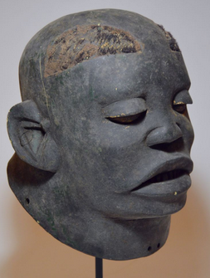 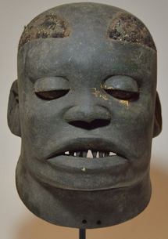 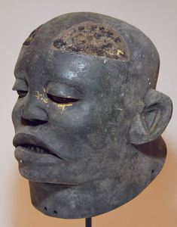 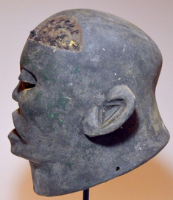 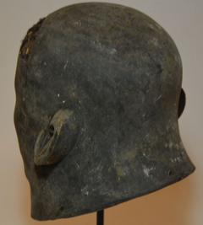

**Formal Label:** Makonde Mask of Tanzania, East Africa

**Accession Number:**

**LC Classification:** NB1310

**Date or Time Horizon:** early 20th century

**Geographical Area:** Tanzania

**Cultural Affiliation:** Makonde

**Medium:** “black wood,” *Dalbergia melanoxylon* or mpingo, charcoal pigment, and black fiber for hair patches.

**Dimensions: H 11 in, W 8 in  
Weight:**

**Provenance:**

**Condition: some aging from use in village play acts.**

**Discussion:**

The Makonde have their own Bantu language and they originated on the Mueda Plateau in Mozambique. When some migrated to Tanzania the Ruvuma River divides those in Tanzania (the Makonde) and those in Mozambique (the Maconde). In both regions their indigenous religion centers on ancestor worship (despite the inroads of Islam and Catholicism) and their masks emulate deceased members of their extended family groups. Those involved in play-acting of the deceased develop scripts that engender the main attributes of those who have passed on as a device for others to emulate, especially in their elaborate puberty rites.

**References:**

Fagg, William Buller. 1980. Makonde. In Masques d'Afrique dans les collections du Musée Barbier-Müller. pages 154-155. Geneva: Editions Fernand Nathan.

Masques d'Afrique dans les collections du Musée Barbier-Müller. 1980. Geneva : Editions Fernand Nathan.

Stoner, John. 1998. Makonde. New York: The Rosen Publishing Group.